This purpose of this document is to outline the steps required for having external people securely upload files to our server using SFTP.
SFTP (Secure File Transfer Protocol) works over the Secure Shell (SSH) data stream to establish a secure connection and provide organizations with a higher level of file transfer protection. This is because SFTP uses encryption algorithms to securely move data to your server and keep files unreadable during the process, and authentication prevents unauthorized file access during the operation.
- You need to download and install a Client, we recommend WINSCP which can be downloaded here: https://winscp.net/eng/download.php
- Once installed we connect using these settings
  - File Protocol: SFTP
  - Host Name: transfer.natureserve.org
  - Port Number: 22
  - User Name Given upon request
  - Password: Given upon request
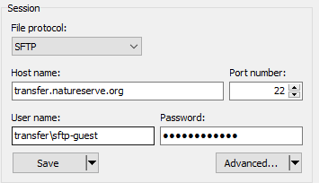
  - Log in
Note: you will be prompted with a warning the first time and you will choose “Yes” to establish a trust between the server and you
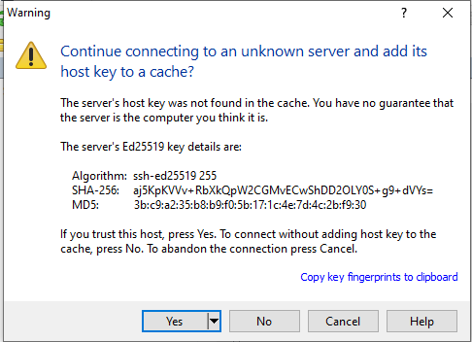
- Once logged in you will be presented with the following screen
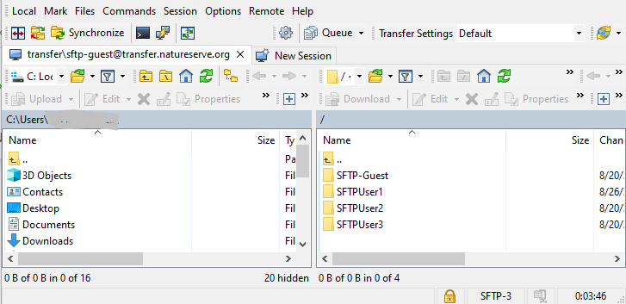
  - The window on the left is “your” computer, on the right is our server
  - Open your SFTP- folder on the right
  - Locate the file you wish to send us on “your” computer,
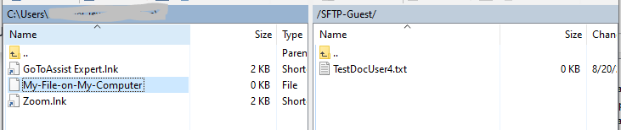
  - And drag it(across) into the SFTP-Guest Folder (or subfolder as directed)
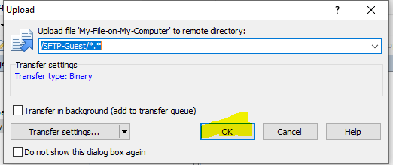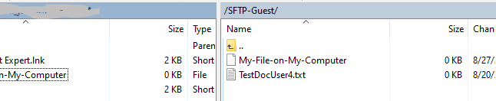
- [X] out/ close the window when complete, and confirm you wish to terminate the session.
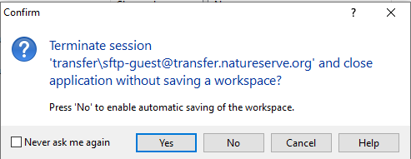
You can choose to save the session/workspace if you will be using this service again

