SFTP (Secure File Transfer Protocol) works over the Secure Shell (SSH) data stream to establish a secure connection and provide organizations with a higher level of file transfer protection. SFTP uses encryption algorithms to securely move data to your server and keep files unreadable during the process. Authentication prevents unauthorized file access during the operation.
- Download and install a Client - we recommend WINSCP which can be downloaded here: https://winscp.net/eng/download.php
- Once installed, connect using the following settings:
  - File Protocol: SFTP
  - Host Name: transfer.natureserve.org
  - Port Number: 22
  - User Name: submit a ticket to the ERT Help Desk by emailing ert@natureserve.org to request password for your transfer site
  - Password: submit a ticket to the ERT Help Desk by emailing ert@natureserve.org to request password for your transfer site
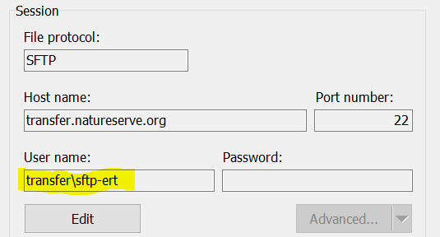
  - And, Log in
Note: you will be prompted with a warning the first time; select Yes to establish a trust between the server and your computer.
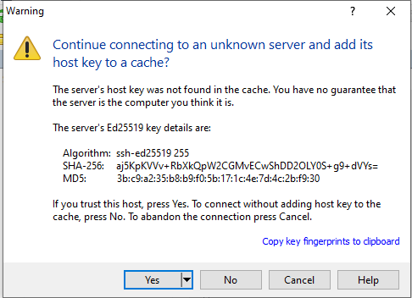
- Once logged in the following screen is displayed:
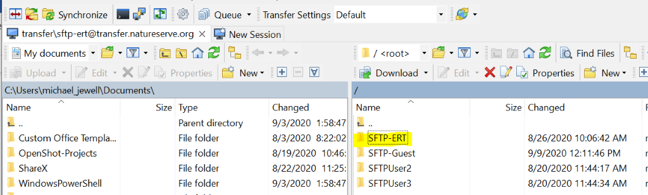
  - The window on the left is “your” computer, on the right is our server
  - Open the SFTP-ERT folder on the right
  - Locate the file you wish to send us on “your” computer,
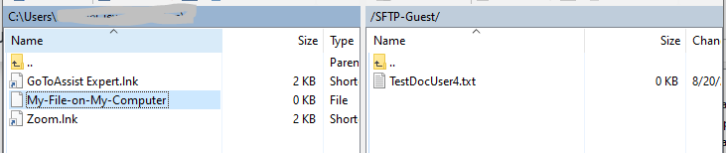
  - Drag the file (across) into the SFTP-ERT Folder (or subfolder as directed)
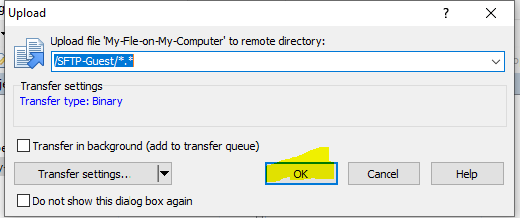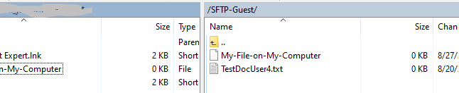
- [X] out/ close the window when complete, and confirm you wish to terminate the session.
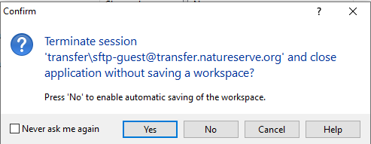
You can choose to save the session/workspace if you will be using this service again
NatureServe Staff will have access these files from inside the network via file-share, or can download them from this site by dragging files from Right-to-Left on WNSCP
File Share: \\transfer\SFTP-Uploads\SFTP-ERT (\subfolder)

