These steps were successfully tested using Crystal Reports version 8.5 & SAP Crystal Reports 2013 Support Pack 1 Version 14.1.1.1036 CR Developer, Product Type: Full.
- Add a group (click Insert --> Group). Use a field that distinguishes your records (e.g., eo.eo_id, ma.managed_area_id, etc.). Leave the Group Options blank.
- Open the Section Expert (click Report Section Expert). Scroll down to Group Footer and click on Insert.
- Repeat step 2 so that you have a Group Footer #1a and Group Footer#1b.
- For Group Footer#1b put a checkmark next to Keep Together and New Page After.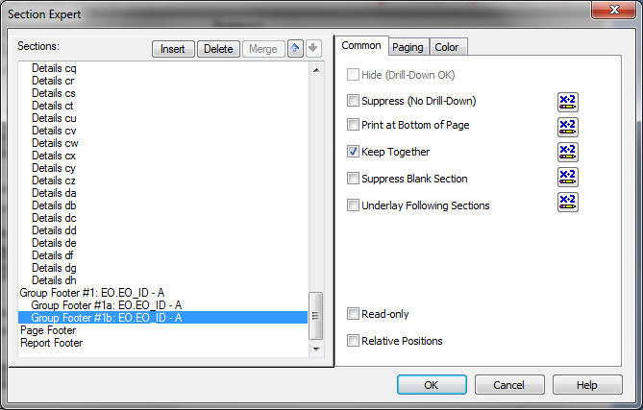
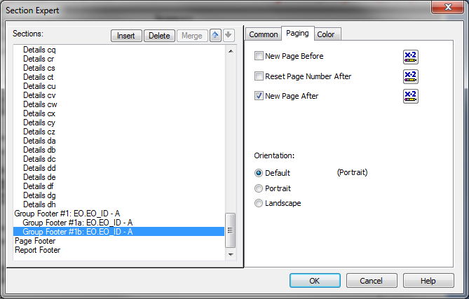

- For Group Footer#1a put a checkmark next to Keep Together. 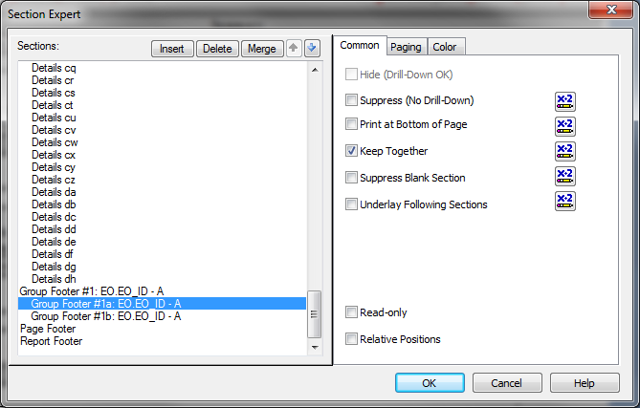

- For New Page After, do not put a checkmark next to it but DO open the formula window and enter this formula:
Remainder (PageNumber,2)=1 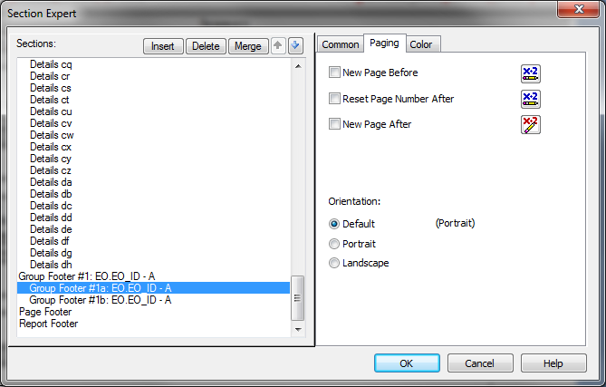
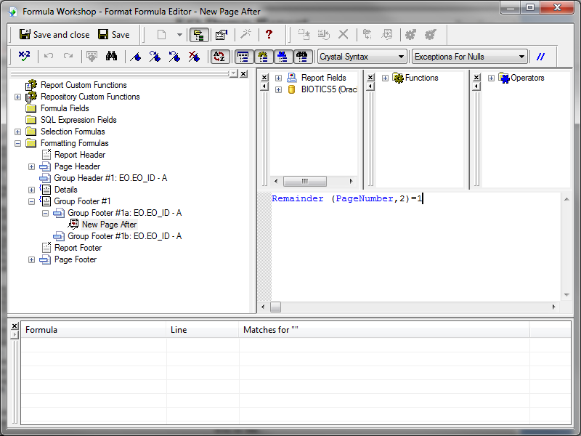
- Save and close the Formula Editor.
- Scroll up to Group Header. Put a checkmark next to Keep Together but leave everything else unchecked and without any formulas.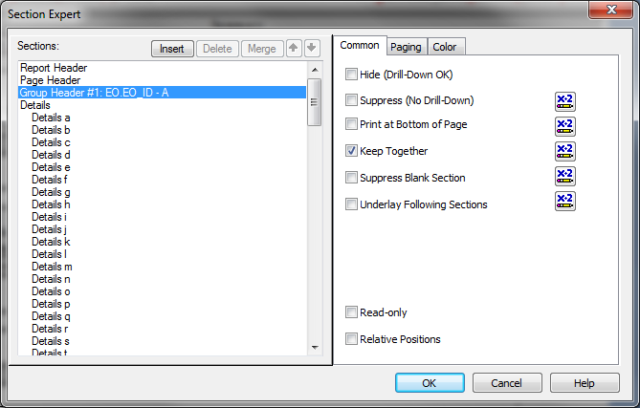
- Click OK to close the Section Expert.
- On the Design tab scroll up if necessary and remove Group Name from the Group Header area.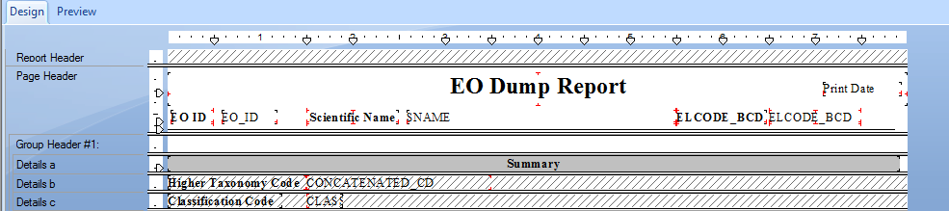
- Shrink the Group Header (grab the lower separator bar and drag upwards) so it doesn’t leave a blank area at the top of your report.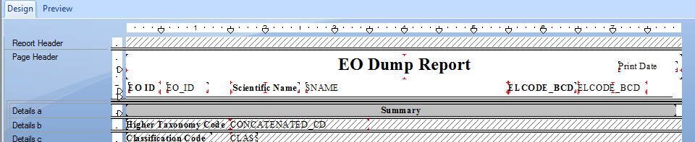
In the resulting printout, the last page of a report will always be on an even page, with just the heading for the page. There may be a way to eliminate that heading but I have not been able to find it.

