Creating Taxonomic Update Biotics Support Tickets, June 10, 2020
So that we can store and track the taxonomic updates that we receive from heritage programs, and those we need to do internally, take the following steps to create a Biotics Support ticket so that we can filter, track and report on the updates that NatureServe Botany and Zoology are doing.

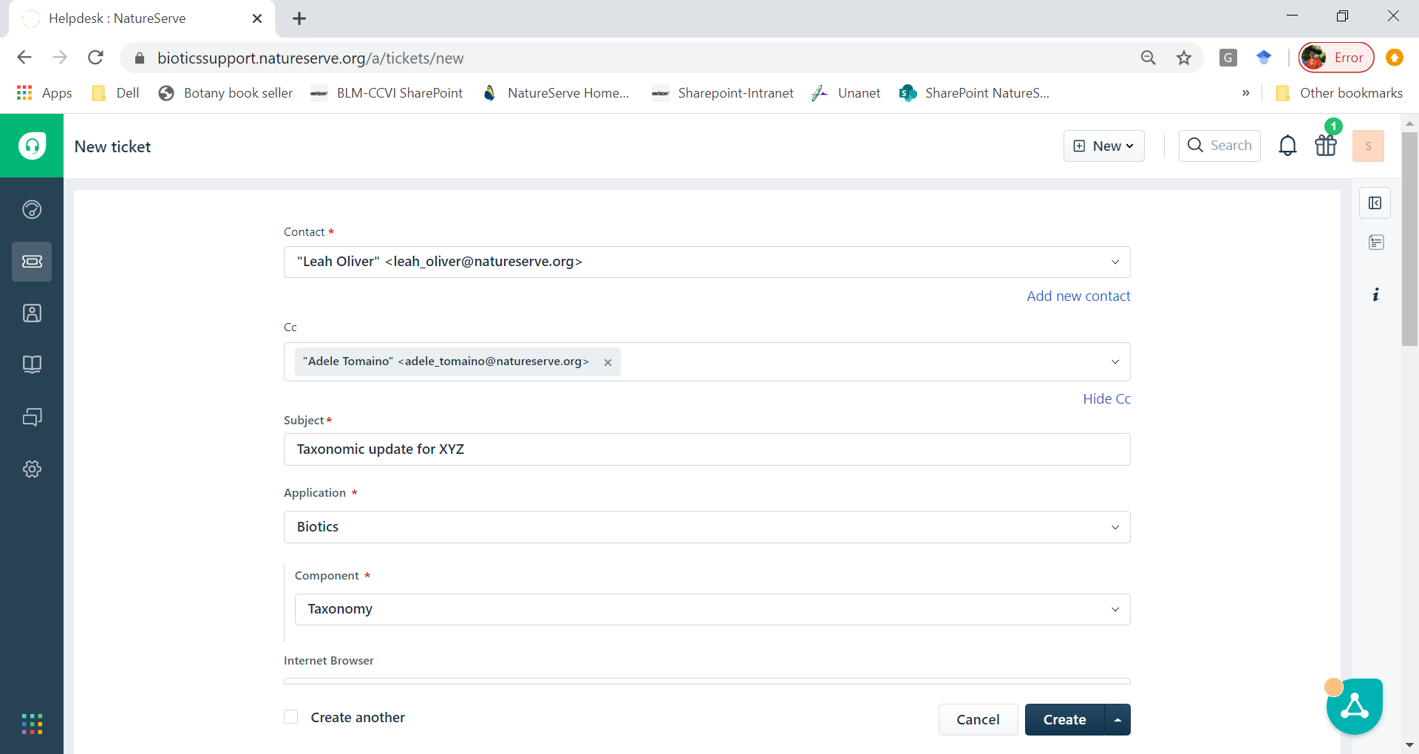
Include genus/ spp. in Subject
Your name goes here
Whoever else - FYI
Select Taxonomy in the Component drop down.

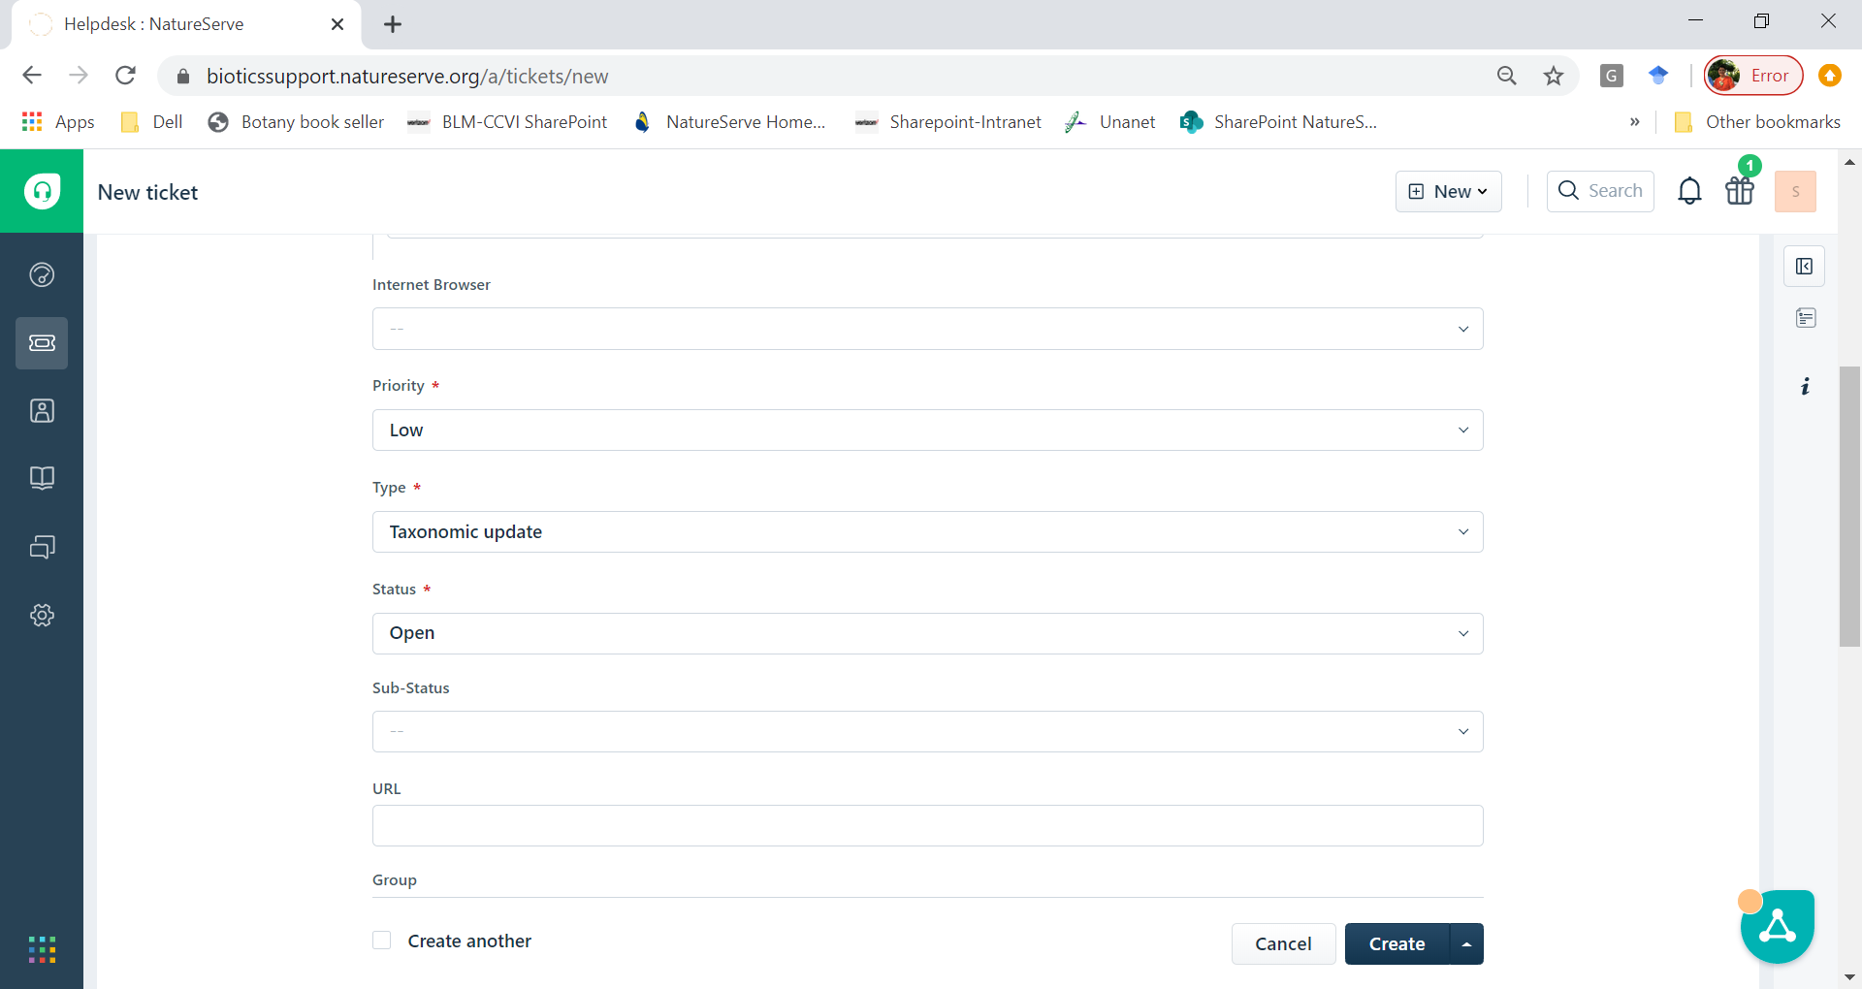
Select Taxonomic Update in the Type drop down.
** This is the most important thing so we can consistently find taxonomic update tickets in Biotics Help.

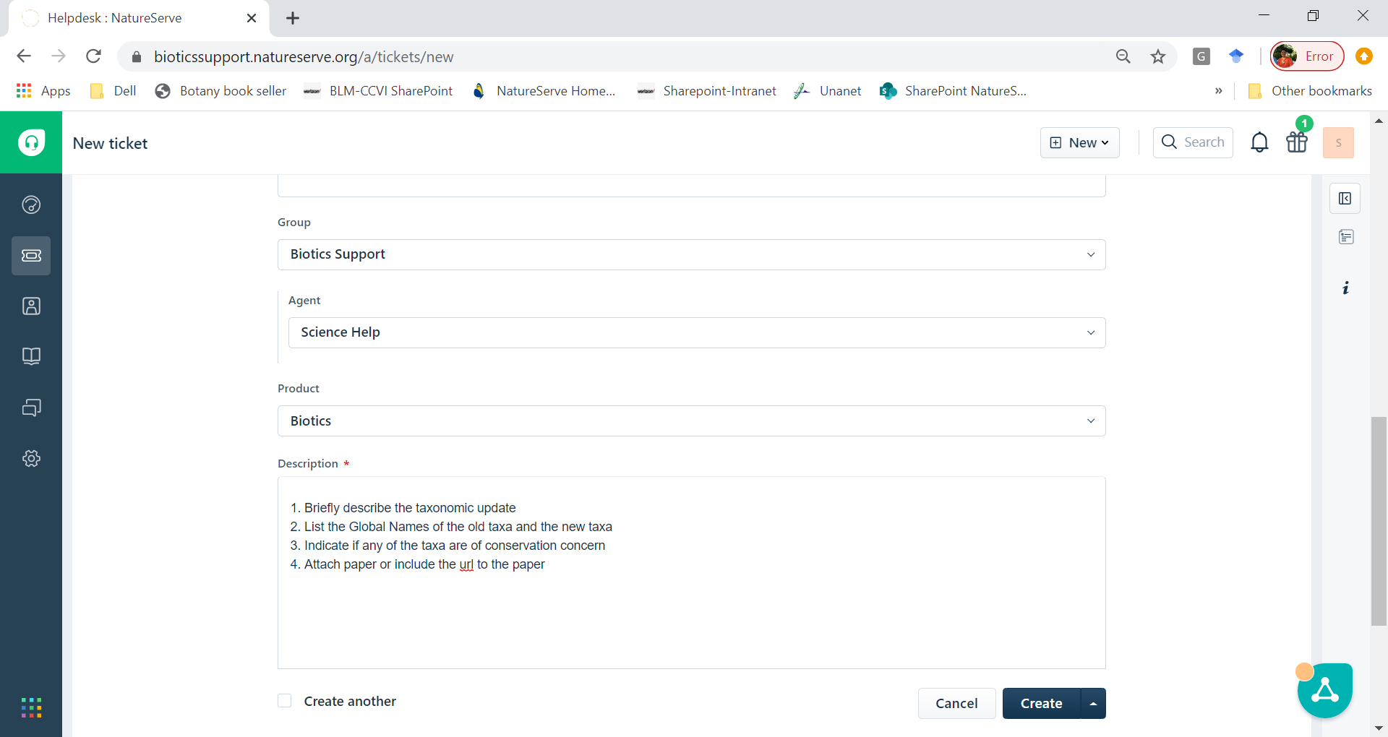
Include these things in the Description

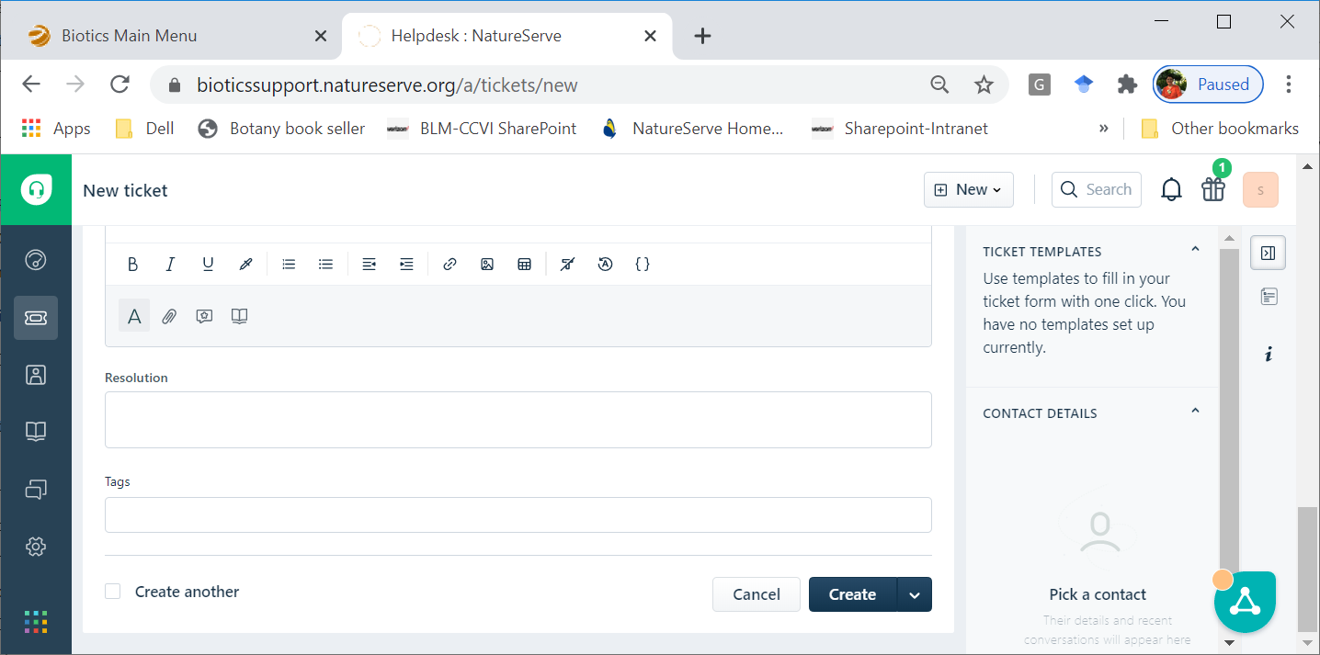
Your Name

